**Cognizant Digital Nurture 4.0**

***WEEK-2 Module 4 - Mockito Tasks***

Firstly, I have included the required dependencies in pom.xml:

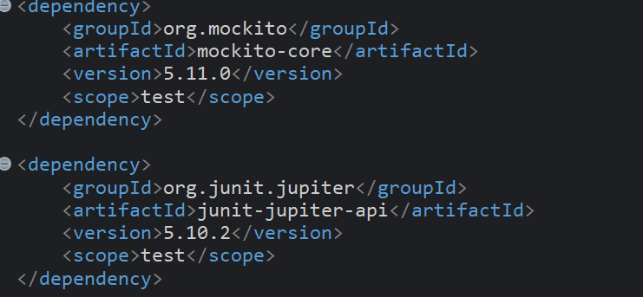

**Exercise 1: Mocking and Stubbing (Mandatory)**

**Scenario:**

You need to test a service that depends on an external API. Use Mockito to mock the external API and stub its methods.

**Steps:**

1. Create a mock object for the external API.

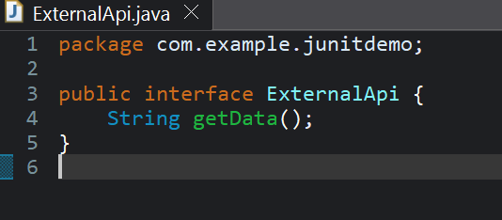

1. Stub the methods to return predefined values.

Creating a service class:

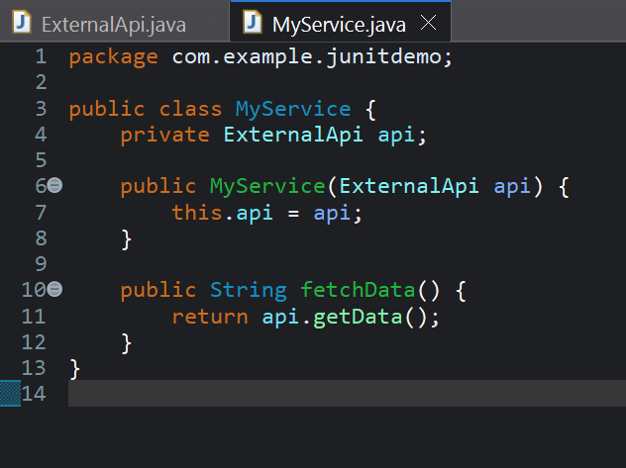

1. Write a test case that uses the mock object.

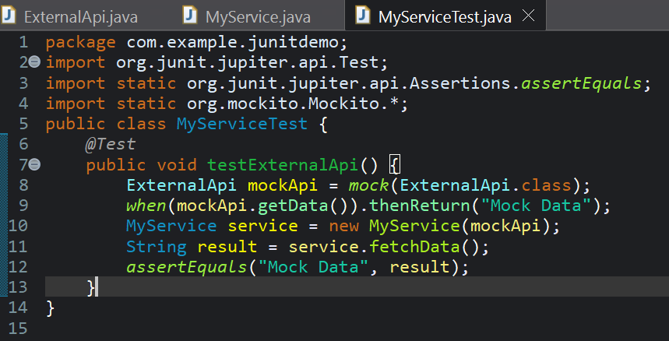

Output:

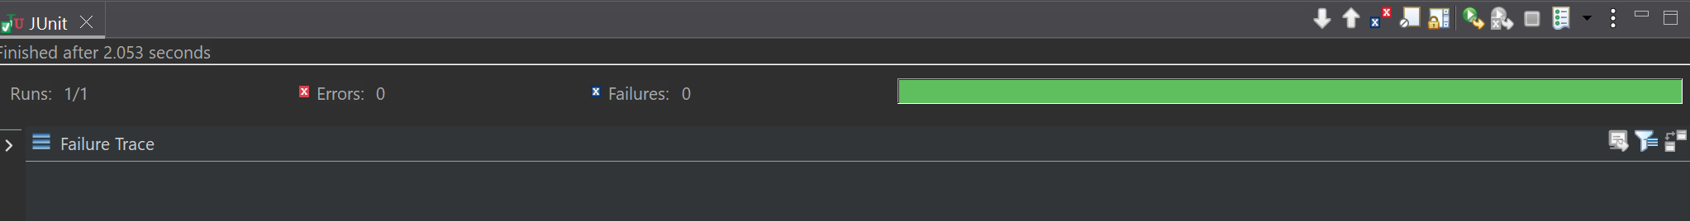

**Exercise 2: Verifying Interactions (Mandatory)**

**Scenario:**

You need to ensure that a method is called with specific arguments.

**Steps:**

1. Create a mock object.



1. Call the method with specific arguments.



1. Verify the interaction.

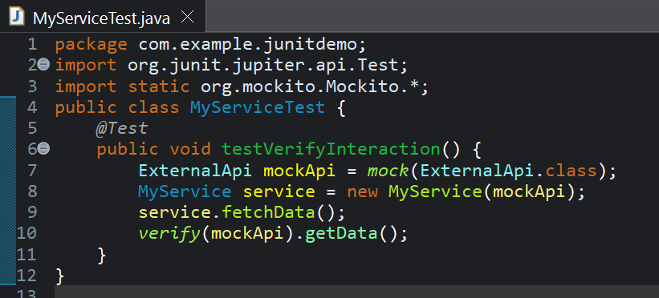

Output:

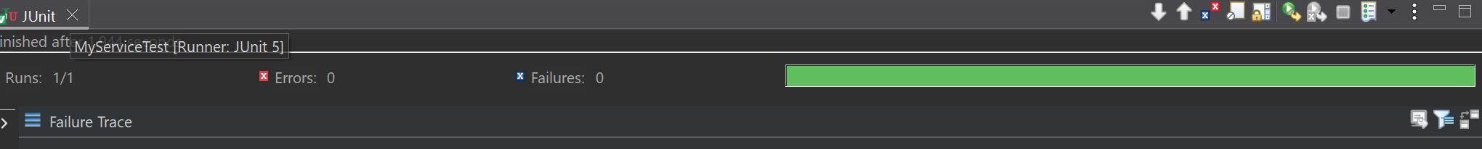

**Exercise 6: Verifying Interaction Order (Non - Mandatory)**

**Scenario:**

You need to ensure that methods are called in a specific order.

**Steps:**

1. Create a mock object.

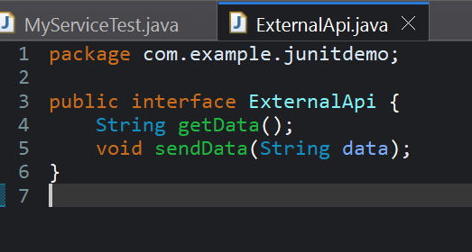

1. Call the methods in a specific order.

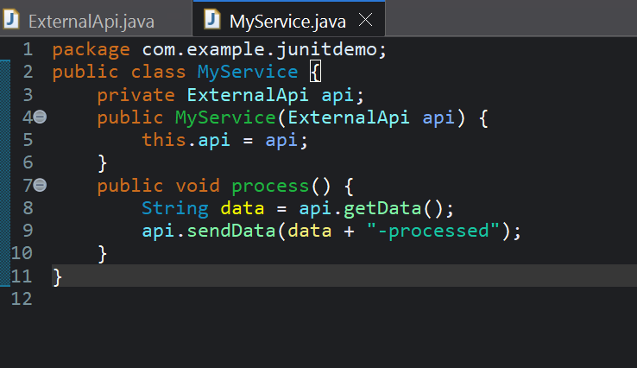

1. Verify the interaction order.

